Telephone Answering Trial – August 2024
COMPANY X (Estate Agent)
Call Data Analysis & Evaluation

Introduction
Paperclip has undertaken a telephone answering trial for COMPANY X. The trial took place over two weeks from 12/08/41 to 26/08/24.

Calls answered over the two-week period totalled 104.

Based on the evaluation of the data generated by this trial, there is an excellent case for COMPANY X to engage Paperclip’s services.

Call Data Analysis

Call Data Evaluation

Due to the urgency of the trial, Paperclip started by taking calls and allocating all messages to a single folder. Consequently, the call ‘categories’ data only applies from half-way through the trial.

Financials
The trial referenced in this report was provided free of charge. As an active account the service would have been invoiced at £232.05 + VAT. This would include:

- Service charge: £42.50 + VAT (equates to £85.00 per month)
- Call minutes: £189.55 + VAT (223 minutes @ 85p/minute)

Investment allocation
Although clients enjoy a broad range of benefits by engaging Paperclip’s services (summarised in the following section), many clients tend to focus primarily on sales leads.

Sales leads
- 3 property valuations were captured during the trial
- 1 instruction was confirmed during the trial
Customer Service
- 15 viewings were captured during the trial
- 7 offers were captured during the trial

Non-financial benefits
In addition to client retention (customer service) and client acquisition (sales leads) there are many benefits to using Paperclip’s services, including:

- Peace of mind: Paperclip answer 98% of all calls and 80% of calls within 20 seconds
- Scope: Paperclip operates 8am–6pm on weekdays and 9am-4pm on Saturdays. We capture calls when your office is closed and when you experience absences such as sickness, holidays and training.
- Sales: Paperclip works with clients to handle increases in call volumes linked to marketing activities such as advertising and exhibitions.
- Work environment: unanswered phones ringing, both in reception areas and in offices, are a major distraction and detract from the quality of the working environment.
- Nuisance: Paperclip screened nuisance/sales calls to minimise disruption to the COMPANY X team.
- Continuous improvement: as Paperclip builds its relationship with COMPANY X, the service provided will be developed and refined. For example, if desired, bespoke call handling rules can be established for each COMPANY X team member.

Proposal
Based on the call data analysed in this report, we believe that the substantial benefits generated for COMPANY X, in terms of customer service and sales lead generation, outweigh the charges that would have been incurred.

We propose that COMPANY X engages the call answering services of Paperclip on a permanent basis. These can be implemented as provided during the trial, or can be refined to meet more specific requirements.

I look forward to discussing the findings of the trial with you in person.

Yours sincerely

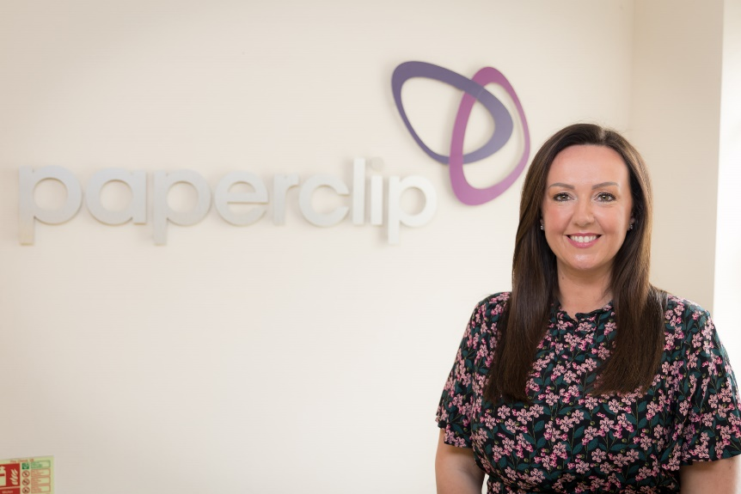

Louise Bellwood
Business Director
Tel: 01246 418 181
Email: louise@paperclip.co.uk

